Welcome to Redhill Robins Pre-school
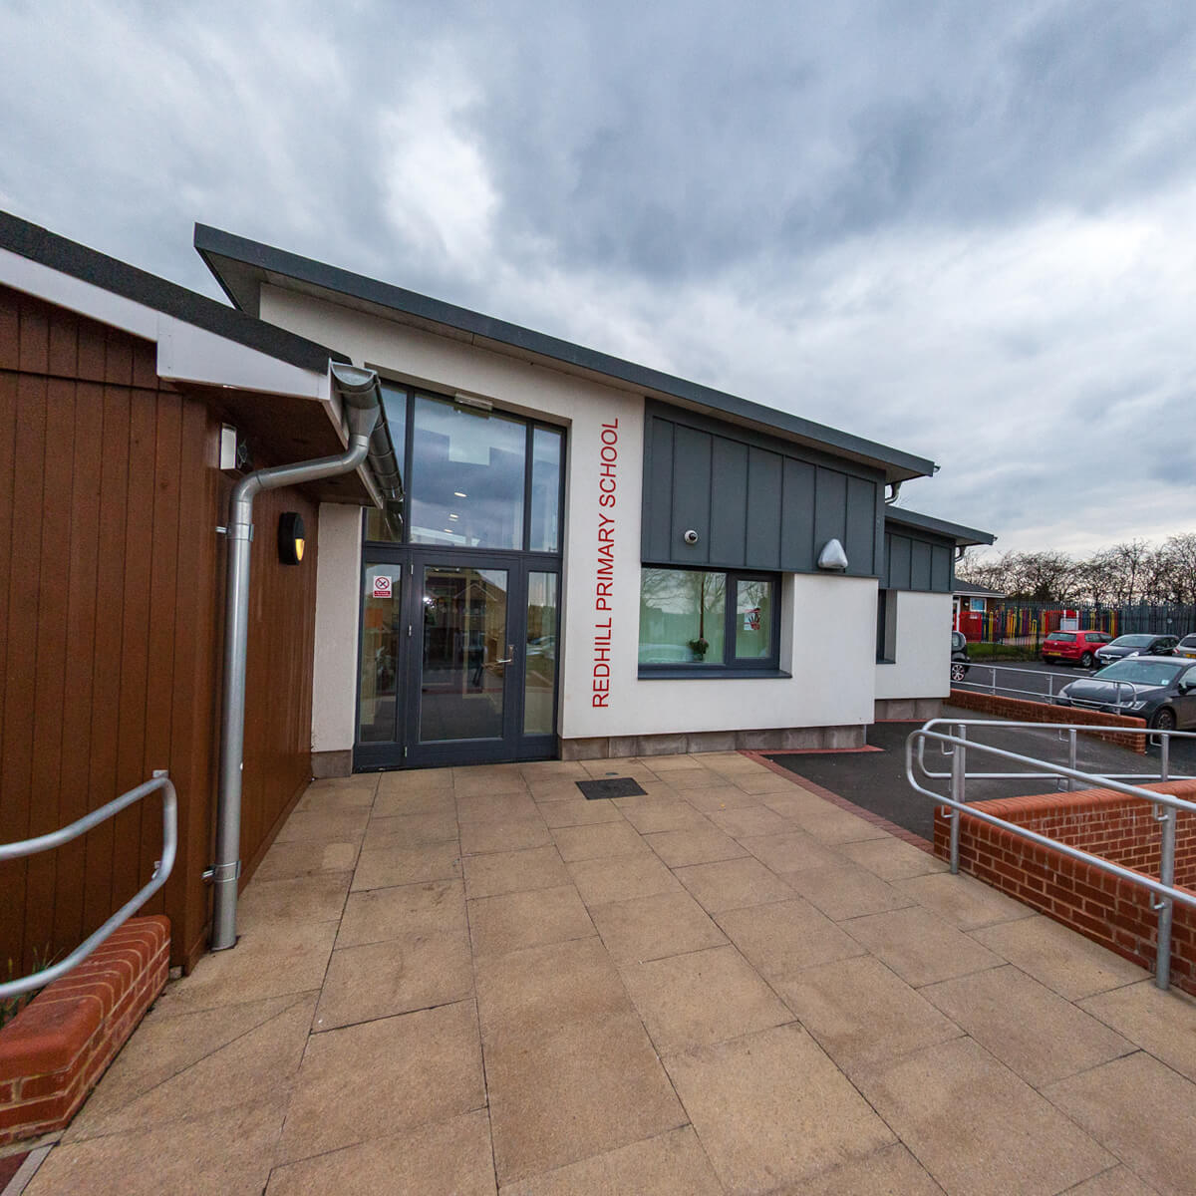
Wrights Avenue
Chadsmoor
Cannock
WS11 5JR
Telephone: 01543 227140
Head teacher: Mrs Libby Banks
Contents
Meet the team p 3-4
Introduction to Redhill Robins / Our Vision p 5
Home – School Partnerships p 6- 7
Important information about Redhill Robins Pre-school p 7-11
Early Years Curriculum p 12
Safeguarding p 13
Promoting positive behaviour p 14
Additional information p 14-16

Reviewed & Updated December 2020

Meet the team
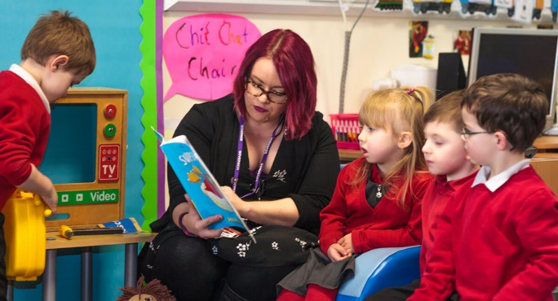
Hello, my name is Miss Claire Freeman (Redhill Early Years Lead). I have over 12 years experience as an Early Years Practitioner in Nursery and Reception. I have a passion for developing early language and a love reading. I particularly enjoy sharing exciting stories, songs and information books with children. I enjoy using storytelling as a tool to bring the books to life. I strive to help children to expand their vocabulary. I strive to personalise learning to meet children’s needs and interests, creating an exciting learning environment which supports self- discovery and independence. I am passionate about the EYFS and continue to research and use new initiatives to ensure the Early Years Provision at Redhill is as effective as possible for all children. I look forward to working closely with families and supporting your child’s development through these vital early steps in education.
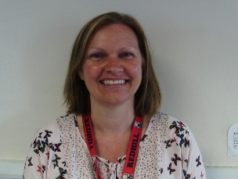
Mrs Emma Jukes over 25 years qualified as an Early Years Practitioner (Lead Practitioner in Redhill Robins- Level 6). I have always been passionate about providing quality experiences for children to learn through play and exploration. I am highly motivated to build positive relationships with our families. You, as parents and carers, are your child’s primary care giver and I value your expertise and knowledge of your child. I look forward to our journey, working together to provide the best opportunities for your child.
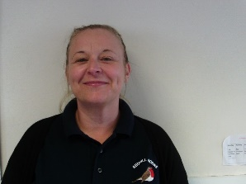
Mrs Susan Dean over 16 years qualified as an Early Years Practitioner (Level 3).
I am passionate about building quality relationships with children so that they are happy within our setting. I love to share stories and engage in role-play with the children. I enjoy observing children using their imaginative to develop their language and social skills.
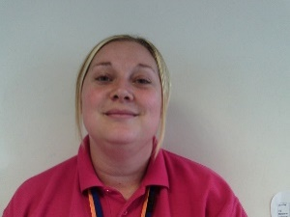
Miss Kayleigh Jones over 13 years qualified as an Early Years Practitioner (Level 3).
I am dedicated to helping children to challenging themselves in all areas of the curriculum ensuring they reach their full potential. I am particularly passionate about developing Literacy and self-help skills. I feel very proud when watching the children grow and develop within our setting.
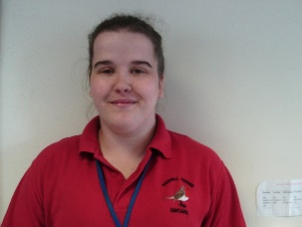
Miss Chloe Evans over 8 years qualified as an Early Years Practitioner (Level 2)
I am a very calm and patient person allowing children time to express their wants and needs. I am committed to provide quality childcare for all of our children.
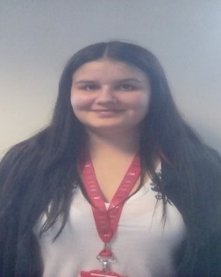
Miss Ellie Smith- 2 years experience as an Early Years Practitioner (Level 2)
I am in my final year of training to become a level 3 Early Years Practitioner. I have already completed two years of work experience within our Early Years department. I am committed to getting to know each child individually. This enables me to cater for children’s various needs, helping children feel happy, safe and valued during their time at Robins.
ALL STAFF ARE FIRST AID TRAINED

Introduction
Welcome to Redhill Robins, a purpose built Preschool and Nursery for children aged 2-4 years.
Our strong key worker system ensures your child receives the best individualised learning support, with adults working alongside families to build and embed key life skills such as self-confidence, listening and attention and physical development. We aim to prepare your child for their next steps in education.
At Robins, we promote independence. Children are supported to take ownership of their own self- help skills including safety, hygiene and toilet care. Children have freedom to explore the setting, leading their own play, guided by responsive and caring adults. Through quality interactions and focused assessments, adults provide activities that cater to children’s interests and next developmental steps.
Our outdoor area is used daily to promote our children’s health and well-being. Through a range of activities and resources, we support and challenge our children as they develop their gross motor skills such as running, jumping, balancing and climbing.
We feel that the outdoors provides an excellent environment for developing social skills, speaking and listening and mark making. Learning outside creates an atmosphere of exploration, imagination and problem solving, encouraging children to use their senses to explore the world around them.
At Redhill Robins, we begin our journey as early readers and writers by prioritising speech development. We aim to create an environment rich in language, rhyme and story.
We aim to work in partnership with children, families and colleagues to provide a safe, caring and inspiring learning environment, where children can establish a love of learning from an early age.
Our Vision
The Redhill Early Years Team strive to create a safe, exciting and inspiring learning environment, which is reactive to children’s learning needs and interests. We provide a safe but challenging learning environment, using interesting resources and experiences, to help children to experiment, explore and discover the world around them. We plan carefully and progressively, introducing new skills and building on prior knowledge.
As a team, we are dedicated to promoting children’s health and well-being. We want our children to be healthy, safe and love learning, so that they continue to develop and grow. We actively promote independence and encourage resilience in all areas of learning. We work tirelessly to help children acquire transferable life skills that will help them to be ready for their next steps in learning. In the Early Years, we place particular importance on speech and language development and early reading by creating a language rich environment, filled with high quality stories, rhymes and talk.
Our dedicated and approachable Early Years team, work in partnership with parents and families to promote learning within the setting and at home, ensuring all children meet their potential. Through our Key worker system, we build close relationships with children, acting as role models for behaviour and learning, providing high quality learning experiences and interactions. All of the children in our setting are valued as individuals. We carefully observe and assess children’s learning, in order to personalise our curriculum and learning environment, to ensure it meets the needs and interests of all children within the setting.
Home – School Partnerships
Staff will:
* Provide a safe, stimulating and caring environment where your child can follow their individual interests as they learn.
* Build children’s self-esteem and confidence through nurture and praise.
* Encourage children’s curiosity, questioning, independence and problem solving, developing positive lifelong attitudes and skills to learning.
* Support children in developing respect, resilience and awareness of their own and other cultures and religions.
* Establish strong partnerships with parents and carers to encourage participation in their child’s learning and development.
* Adhere to policy and procedures such as Changing Policy, Child protection Policy, Admissions policy and equal Opportunities Policy (all relevant policies are available from the main school office or on the school website).
* Work in partnership with other agencies to ensure that families and children are supported and their individual needs are appropriately met.
As parents / carers we ask you to:
* Help to build a positive relationship with Robins for the benefit of your child’s education.
* Read a book with your child every day.
* Keep us up to date with emergency contact details, medical needs and changes to home address.
* Ensure you child attends school regularly and punctually.
*Encourage your child to be independent when dressing and using the toilet.
* Avoid taking your child on holiday during school term time.
* Inform the school of the reason for non-attendance on the first day of absence.
* Engage in workshops, meetings and consultations.
* Support your child’s play and learning at home. Use resources provided to enhance your home learning environment.
* Give permission for any referrals to other agencies or act on advice to seek support from other agencies such as the GP.
* Adhere to all policies and procedures such as medication policy, Child Protection Policy, Admissions Policy and Equal Opportunities Policy (All relevant policies are available from the main school office or on the school website).
* Try to walk to school if possible. If this is not possible, ensure that you park your vehicle safely, not on yellow lines and courteously of other parents and local residents.
* Seek reassurance or an explanation from staff, if you have any concerns. Refrain from using social media as a platform to share concerns about other children, parents or school practices.
* At this time we ask that only one adult at a time comes to drop off and collect their child. Please ensure all adults follow social distancing measures in place (Covid 19 update) Adults are advised to wear face coverings when on site.
One-way system is in place around the school site:
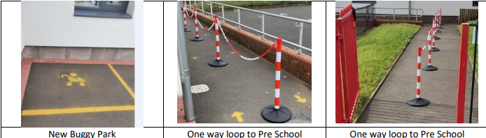
Together we will:
* Encourage your child to be thoughtful, helpful and caring to others.
* Support your child’s learning and confidence in a positive environment.
* Make your child’s first experience of school positive and enjoyable.
* Ensure that your child makes good progress through their early development across all areas of the curriculum.
We look forward to working with you!

Starting at Redhill Robins
During the induction period you will be invited to visit the setting with your child, for a taster session. (Covid 19 – This stay and play may need to be based in the outdoor area. Staff will provide further information on appointment.) You are expected to stay with your child for this to ensure a smooth transition for them and yourselves. Once your child starts attending Robins, you are welcome to stay with them until they are comfortable to stay alone. It is a huge transition for a child to leave their parent or carer for the first time and they may become distressed. We do not feel it is in the best interest of the child to leave them upset. We encourage parents and carers to stay with their child for the first sessions with us and always say goodbye before leaving. This will reassure your child that Robins is a safe place for them to stay. We have a flexible approach to the settling in period to ensure we meet the need of every child as an individual. Please feel free to speak with a member of staff regarding this. We encourage our parents and carers to come into the setting each day to help your child hang up their belongings and settle in to the classroom. Staff members are on hand to help with any children who may become upset. (Covid 19 – During our induction meeting we will plan an individual approach to your child’s induction)
Nov 2020 / Dec 2020 – Following Local Public Health guidance - Al induction sessions with a parent have been suspended whilst in national or local lockdown (Tier 3)

Key worker information
We have highly qualified and highly motivated staff, who hold decades of experience within the profession of educating young children. Each staff member is responsible for a group of children, known as a key worker group. Your child’s key worker is responsible for helping you and your child to settle in at Robins, plan activities for your child and keep records of your child’s progress. They will be able to assist you with any questions or concerns you may have. However, you are more than welcome to speak with any member of staff who will be happy to help you. You will be notified of your child’s key worker during the settling in period.
Covid update: Following Government guidance from September, we will be creating family groups or bubbles. These family groups will work closely with their key worker when accessing the indoor and outdoor area. There will be enhanced cleaning schedules in place as each bubble accesses the activities and resources. We will share further information about the routines of the day and our Key worker system over the coming weeks.
What your child will need
When your child attends they will need to bring the following:
Drinks bottle ( Please label with your child’s name.)
Two or three changes of clothes including underwear and socks / tights. These will need to be left in school in a named carrier bag. (Covid 19 update)
If your child is in nappies please provide spare nappies and baby wipes. These will need to be left in school in a named carrier bag. (Covid 19 update)
We play outdoors in all weather conditions. Please send your child in clothing and footwear appropriate for the weather (rain coat, wellington boots, winter coat, sun hat). Please apply sun cream in hot weather. With your permission, we can re-apply sun cream provided by you if needed (please see sun cream policy).
All belongings must be labelled with your child’s name.
No toys or comforters from home are permitted into the setting. – Covid 19 update
School uniform is optional – red jumper / cardigan, white blouse / shirt, grey trousers / skirt, black shoes. Please send your child in clothes that are easy for them to manage. Trousers and skirts that have elasticated waist are ideal for encouraging independence during toileting. We have aprons available in the setting. However, be aware that in Early Years, we take part in lots of messy play and clothing may get soiled by pen or paint.
If your child attends for a ½ day session only (morning or afternoon), they do not need to bring a packed lunch as children can have their lunch at home before or after their nursery session.
Only children who are staying all day will need to provide a packed lunch in a lunch box or bag. There will be no hot dinners provided for Nursery children until further notice. – COVID 1
Session times and routine
Your child can attend for a morning session, afternoon session or all day. Your child’s session times can be arranged or altered by speaking to a member of staff in the main school office. We can also help you to apply for any funding (Think 2 / Early Years Pupil Premium) you may be eligible for.
The session times are:
Morning – 8:45am-11:45am
Afternoon – 12:15 - 3:15pm
All day – 8:45am-3pm
Fees and Funding:
- Paid Session Prices are £10.00 for a half day or £20.00 for A whole day
- 2 year old Think 2 funded places are available for eligible families.
- 3-4 year old are entitled to 15 hours free universal child care.
- A limited number of 30 hour funded places are available for eligible 3-4 year olds.
What happens during a typical day at Redhill Robins?
Rhythm of the day at Redhill Robins
Covid 19- Session times may be slightly altered to allow for staggered intake and enhanced cleaning schedule. Further information to follow.
Morning | The daily Routine | Afternoon
9:00-9:15 | Arrive and settle, self-register with parents | 12:15  (11:45-12:15 lunch for children who stay all day / cleaning between sessions)
9:15-9:30 | Sing hello song and introduce daily activities | 12:15-12:30
9:30-10:45 | Child initiated play | 12:30-1:45
10:15-10:45 | Open snack | 1:15-1:45
10:45-11:15 | Small group time | 1:45-2:15
11:15-11:30 | Child initiated play | 2:15-2:30
11:30-11.:40 | Tidy up | 2:30-2:40
11.40-11.50 | Music | 2.40-2.50
11.50 -12.00  (11.45-12.15 lunch for children who stay all day) | Coats on for home time / sing it’s time to go home song | 2.50-3.00
11:45 | Home time | 3.00
Further Information will follow about drop off collection procedures. (Covid 19 update)
- Some of the activities your child will access during free play / small group work are:
Stories and rhymes, mark making, maths, early phonics, water play, imaginative play, creative / dance activities, outdoor activities, investigation and discovery, celebrations.

Attendance
To help your child build effective relationships with adults and children, it is vital that children attend consistently to ensure that they access all of the learning available. Please ensure that you sign the attendance register when dropping off and collecting children.
If your child is absent, it is parents / carers responsibility to inform the setting by calling the Redhill school office (01543 227140). It is part of our duty of care to know where children are if they are unable to attend. As part of our school policy, we complete safe and well home visit checks if your child has been absent for 3 days. Poor or inconsistent attendance can also affect your child’s access to funding. For more information please see our Attendance Policy.
Sickness
If your child is not well and will be absent. Please inform the school office by phone call on the first day of sickness. (01543 227140)
To prevent the spread of infection and sickness we follow these health guidelines:
Reason for absence | Period to remain off school
Suspected Covid 19 Symptoms  New continuous cough and / or high temperature, loss of taste or smell | Children, staff or parents displaying any of the Covid 19 symptoms must not attend the setting.  Please inform the school and contact the NHS Track and Trace service to arrange a test (Please see poster below for further information). All children under the age of 5 are now eligible for testing.  If child, staff or parent tests positive they must self-isolate for 10 days.  The rest of household must self-isolate for 14 days.  Please follow the advice from the NHS track and trace team.
Covid -19 Soft Symptoms  STAFFORDSHIRE – From November 2020 | Anyone with one of the main symptoms of persistent cough, high temperature, new cough or loss of taste or smell must self-isolate immediately & book a test.  However many people displaying other symptoms are being asked to get tested as a precaution.  These ‘soft’ symptoms include:  Headaches  Aches and pains  Feeling tired for no good reason  Sore throat  Runny nose  Sneezing  Sometimes tummy ache in children.  People with these symptoms can still go to school or work if they are well enough & only isolate if the test comes back positive.
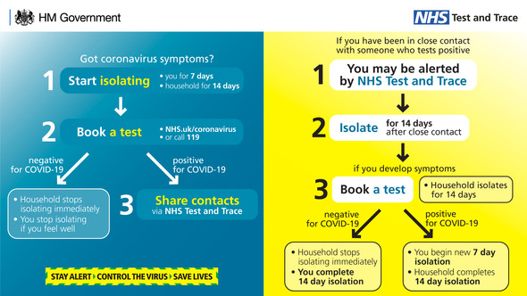

Diarrhoea and vomiting | 48 hours from last episode of diarrhoea and vomiting
Conjunctivitis | Child can return after first treatment
Hand, foot and mouth | None
Scarlet fever | Child can return 24 hours after starting appropriate antibiotic treatment
Head lice | None (please check your child’s hair frequently. If required, head lice treatment and advice can be obtained from your local chemist)
Meningitis | Until recovered
Mumps | Five days after onset of swelling
Chicken pox | Once all blisters are crusted
Ringworm | None – but treatment is recommended
Impetigo | Until lesions are crusted and healed
Scabies | Child can return after first treatment

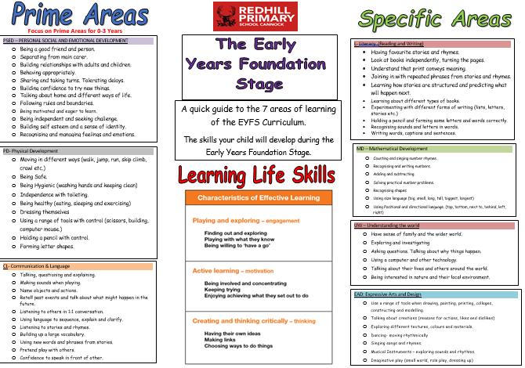Safeguarding
EYFS Curriculum
We have a duty of care to each child within the setting to ensure they are safe from harm. We uphold this in the following ways:
- All staff are DBS checked
- Our Building - Our perimeter is surrounded with fencing and gates are locked. The main door works on a security locking system. This means it CANNOT be opened from outside without inputting the security code. Please press the button on the silver panel outside and wait for a member of staff to open the door from inside. If you are leaving the building please fully press the exit button, located to the right of the door above the fire extinguishers, then you may exit. If the door is forced open the locking mechanism may become less effective. Please take care when using the door.
- Collection – Please let a member of staff know if anyone different will be collecting your child. A mutually agreed password can be provided for collection. Staff WILL NOT allow a child go with somebody we are not familiar with. Children CANNOT be collected by another child under the age of 16.
- Medication – Should your child require any medication please inform a member of staff immediately. Following our medication policy, we are able to administer medication that is prescribed by your GP if it is required to be taken four times a day. The medication must have the GP label on with your child’s name and must be within the expiry date.
- Marks - If your child has a mark from home, for instance if they have fallen over and grazed their knee or have a bump on their head, please inform a member of staff so the mark can be recorded in our marks book. This is so we know they have not hurt themselves in the setting.
- Disclosure – If a child tells us about something which we feel will place them in harm, following our safeguarding policy and duty of care, we MUST inform the appropriate agency.
- If you feel a child is at risk of harm you can speak with any member of staff. Alternatively you can make a referral yourself by calling first response. Referrals to first response can be made anonymously.
FIRST RESPONSE CONTACT NUMBER
0800 1313 126

Promoting positive behaviour
We believe that children flourish best when their personal, social and emotional needs are understood, supported and met and where there are clear, fair and developmentally appropriate expectations for their behaviour.
As children develop, they learn about boundaries, the difference between right and wrong, and to consider the views and feelings, and needs and rights, of others and the impact that their behaviour has on people, places and objects. The development of these skills requires adult guidance to help encourage and model appropriate behaviours and to offer intervention and support when children struggle with conflict and emotional situations. In these types of situations staff can help identify and address triggers for the behaviour and help children reflect, regulate and manage their actions.
Our school Rule: Ready, Respectful and Safe.
We focus on positive behaviour and always use positive behaviour strategies to actively praise and promote this to all children. We do this in various ways including:
* Praise specific actions or attitudes – “Thank you for picking all those bricks up” “You tried really hard to finish that jigsaw” “Those were really kind words you used”
* Acknowledge how the child is feeling and voice their thoughts to show understanding – “I know you are sad, but we have to share the cars and take turns” “I know you feel angry and you want to carry on playing, but now it is time to tidy up”
* Give the child prior warning when activities need to change – “It is nearly time to tidy up, one more minute”
* We very rarely need to use time out (calm down time), if we do, a member of staff will talk to a child about their behaviour including what they could do next time, just for a couple of minutes.
For more information please see our Promoting Positive Behaviour Policy.

Supporting British Values
The Department for Education requires all settings and schools to educate children in line with core British values of;
- Democracy
- Rule of law
- Individual Liberty
- Mutual respect for and tolerance of those with different faiths and beliefs

At Redhill we encourage these through our school values. These are known as our ANTLERS:
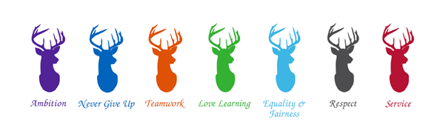

Medical requirements
Please inform a member of staff immediately if your child has allergies or any other medical needs. We will discuss any care requirements for your child and create an Individual Health Care Plan with you if required.

Observation and assessment
As part of the Early Years curriculum we are required to record your child’s progress in all the areas of learning. For this purpose, we use an online observation and assessment programme called Evidence Me. Through this programme you will receive regular reports regarding your child’s development via your email address. We will need you to complete the relevant forms to give us permission to use this programme for your child. This will be discussed with you in detail during the induction period.
As a way of information sharing we use Class Dojo. This is an online programme where staff will keep you informed of any milestones your child achieves whilst at Robins. We will also add home learning and inform you of dates and events. Class dojo can be used as a messaging service between yourself and Mrs Jukes or Miss Freeman. You can also upload pictures or videos to your child’s portfolio to view. For any urgent comments or questions, please contact the school office. In order for us to continue using this messaging service, we ask that interactions remain as positive as possible. Please be advised that staff members may set quiet hours to identify when they will not be checking their messages. We will require permission forms to be completed allowing us to use class dojo with your child.
Photographs
Photographs of your child may be taken for various reasons such as to be placed above your child’s coat peg, observations and displays. Photographs will only be taken by staff on devices which are protected with a password. We will require your permission to take photographs of your child. You are able to opt out of photographs being taken. Please feel free to discuss this with any member of staff. (For further information please see Camera and Imaging Policy)
Complaints
We sincerely hope you will be happy at Redhill Robins and have no need to complain. However, we understand that sometimes you may have concerns. In the first instance please speak to a member of staff. If you feel your concern has not been dealt with effectively, you may ask to speak with our Early Years Lead or Head teacher and follow our school complaints procedure which may be obtained from the school office or on our school website.

ALL OF OUR POLICIES CAN BE OBTAINED FROM THE SCHOOL OFFICE OR THE SCHOOL WEBSITE

PLEASE FEEL FREE TO GIVE US A CALL IF YOU HAVE ANY QUESTIONS
We look forward to starting our journey with you at
Redhill Primary School.

